**JS Advanced Exam**

**Problem 1. Car Dealers**

**Environment Specifics**

Please, be aware that every JS environment may **behave differently** when executing code. Certain things that work in the browser are not supported in **Node.js**, which is the environment used by **Judge**.

The following actions are **NOT** supported:

* **.forEach()** with **NodeList** (returned by **querySelector()** and **querySelectorAll()**)
* **.forEach()** with **HTMLCollection** (returned by **getElementsByClassName()** and **element.children**)
* Using the **spread-operator** (**...**) to convert a **NodeList** into an array
* **append()** in Judge (use only **appendChild()**)
* **replaceWith()** in Judge
* **replaceChildren()** in Judge
* **replaceAll()** in Judge
* **closest()** in Judge

If you want to perform these operations, you may use **Array.from()** to first convert the collection into an array.

**Use the provided skeleton to solve this problem.**

**Note**: You **can't** and you have no permission to **change** directly the given HTML code (index.html file).

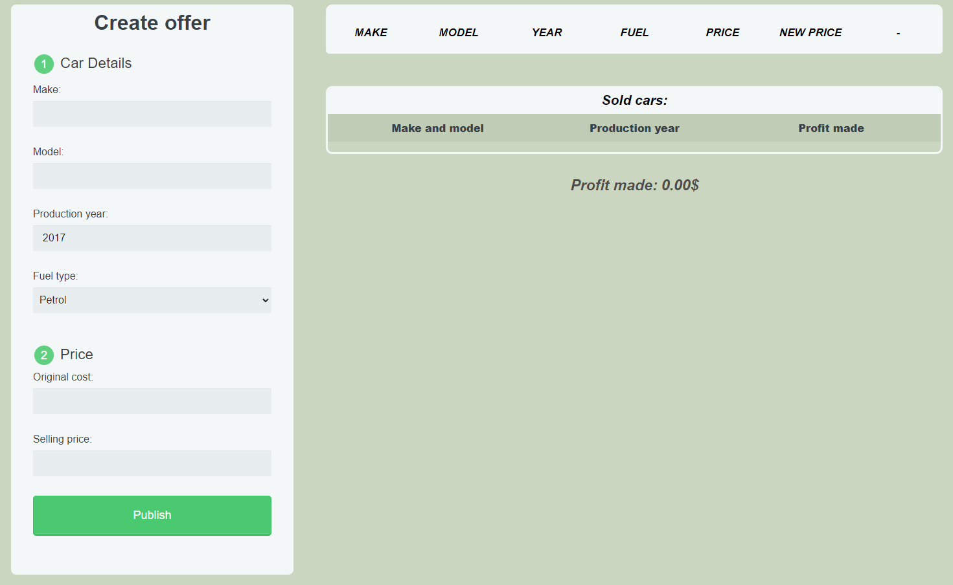

**Your Task**

**Write the missing JavaScript code** to make the **Car** **Dealer** work as expected:

All fields **(make, model, year, fuel, original-cost** and **selling-price)** are **filled with the correct input**

and the **selling price** should have a bigger value than the **original price**

* + **Make, model, year, fuel, original-cost** and **selling price** are **non**-**empty** **strings**. If any of them are empty, or the **original price** is bigger than the **selling price** the program should not do anything.

1. **Getting the information from the form**

When you click the **[“Publish”] button,** the information from the input fields must be added to the **tbody** with the **id “table-body”**. **Then, clear all input fields**.

The HTML structure looks like this:

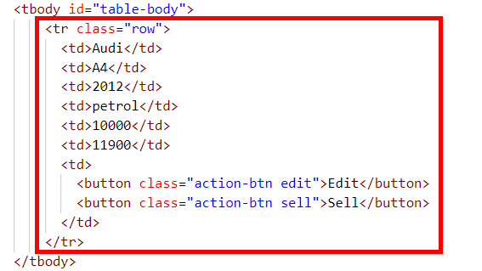

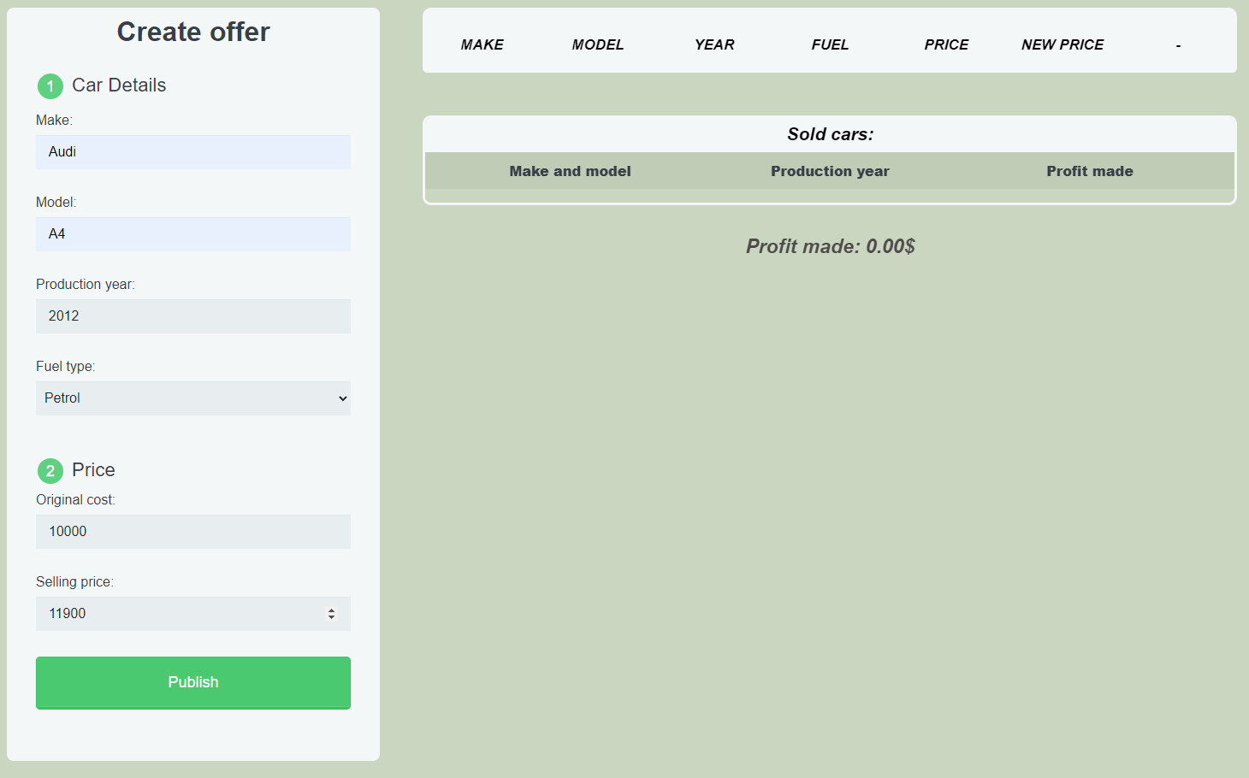

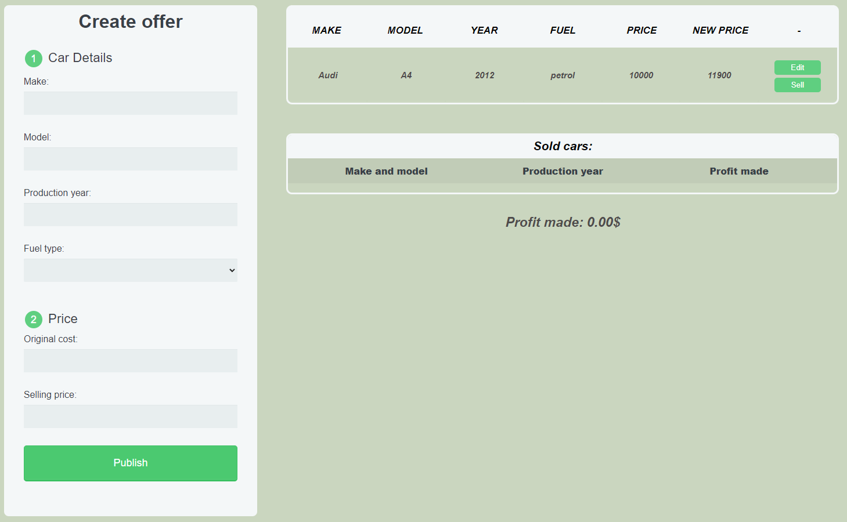

1. **Edit information for posts**

When the **["Edit"]** button is clicked, the information from the post must be sent to the input fields and the record should be deleted from the **tbody** with the **id** **"table-body"**.

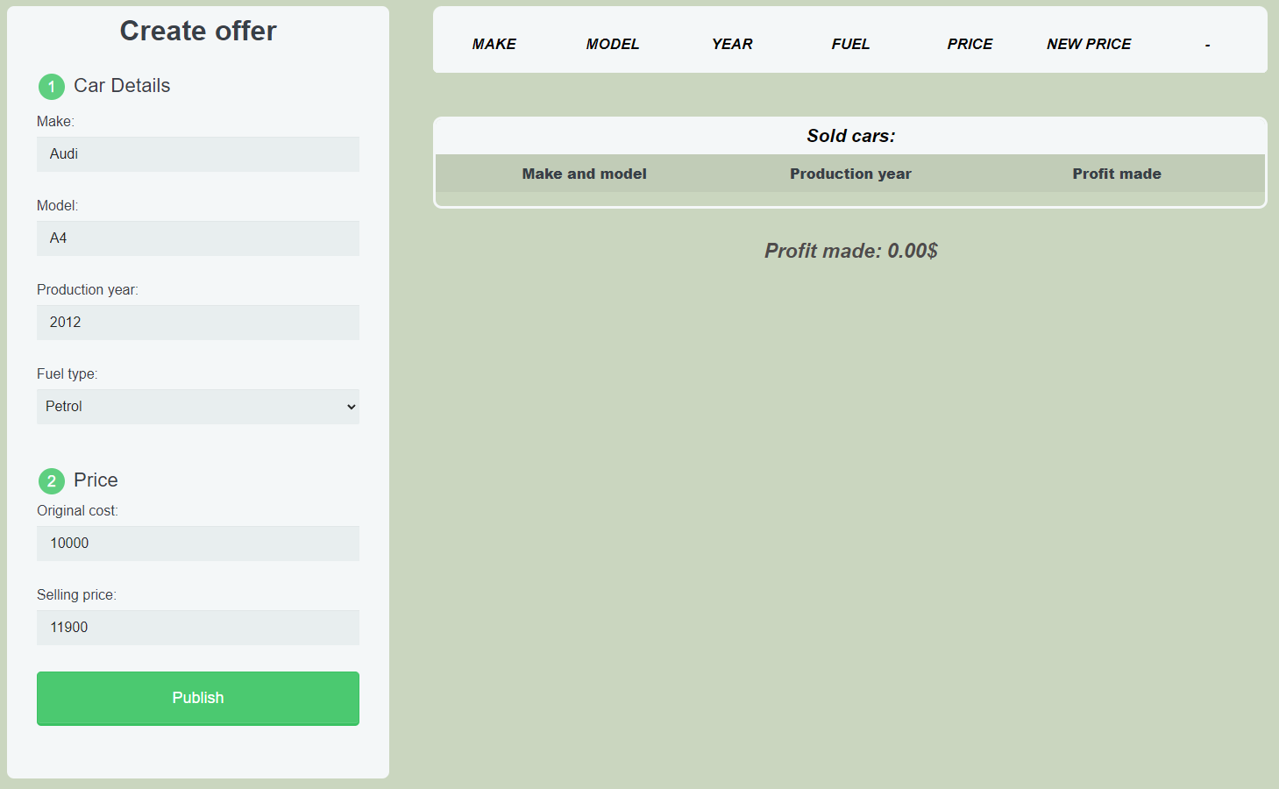

After editing the information make a new record to the **tbody** with updated information.

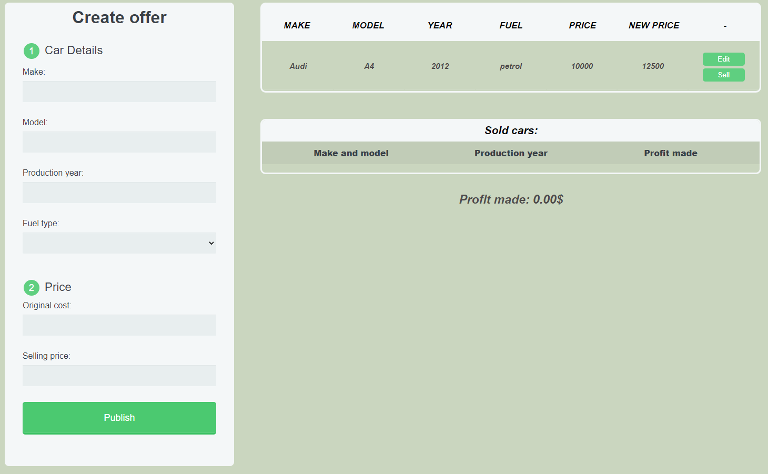

1. **Sell car**

When you click the **["Sell"]** button, the record must be **deleted** from the **tbody** with **id "table-body"** and a new record must be appended to the **ul** with the **id** **"cars-list"**

The new record should be as follows:

* First span should include both car **Make** and **Model** as a whole string and separated by a single space
* Second span should include the **Production year**
* Third span should include the **difference** between the **Selling price** and **Original price**

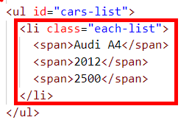

**Total profit** made will be the **sum** from all sold cars profits which should be **rounded** to the **second** **digit** after the decimal point and should be displayed in **strong** with **id** **"profit"**

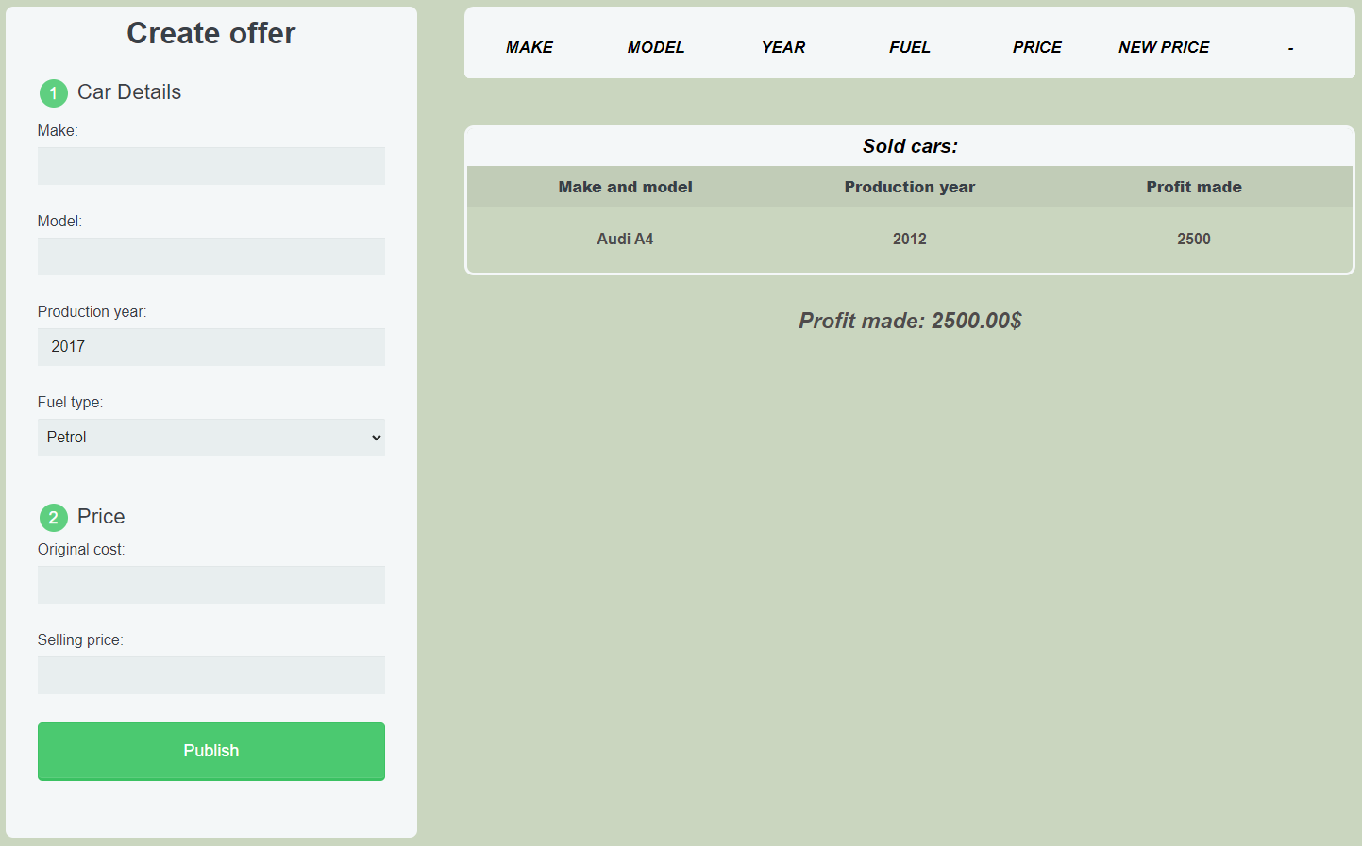

**Submission**

Submit only your **solve()** function.

*GOOD LUCK… ☺*